MOSFET CHARACTERISTICS

TRANSFER CHARACTERISTICS

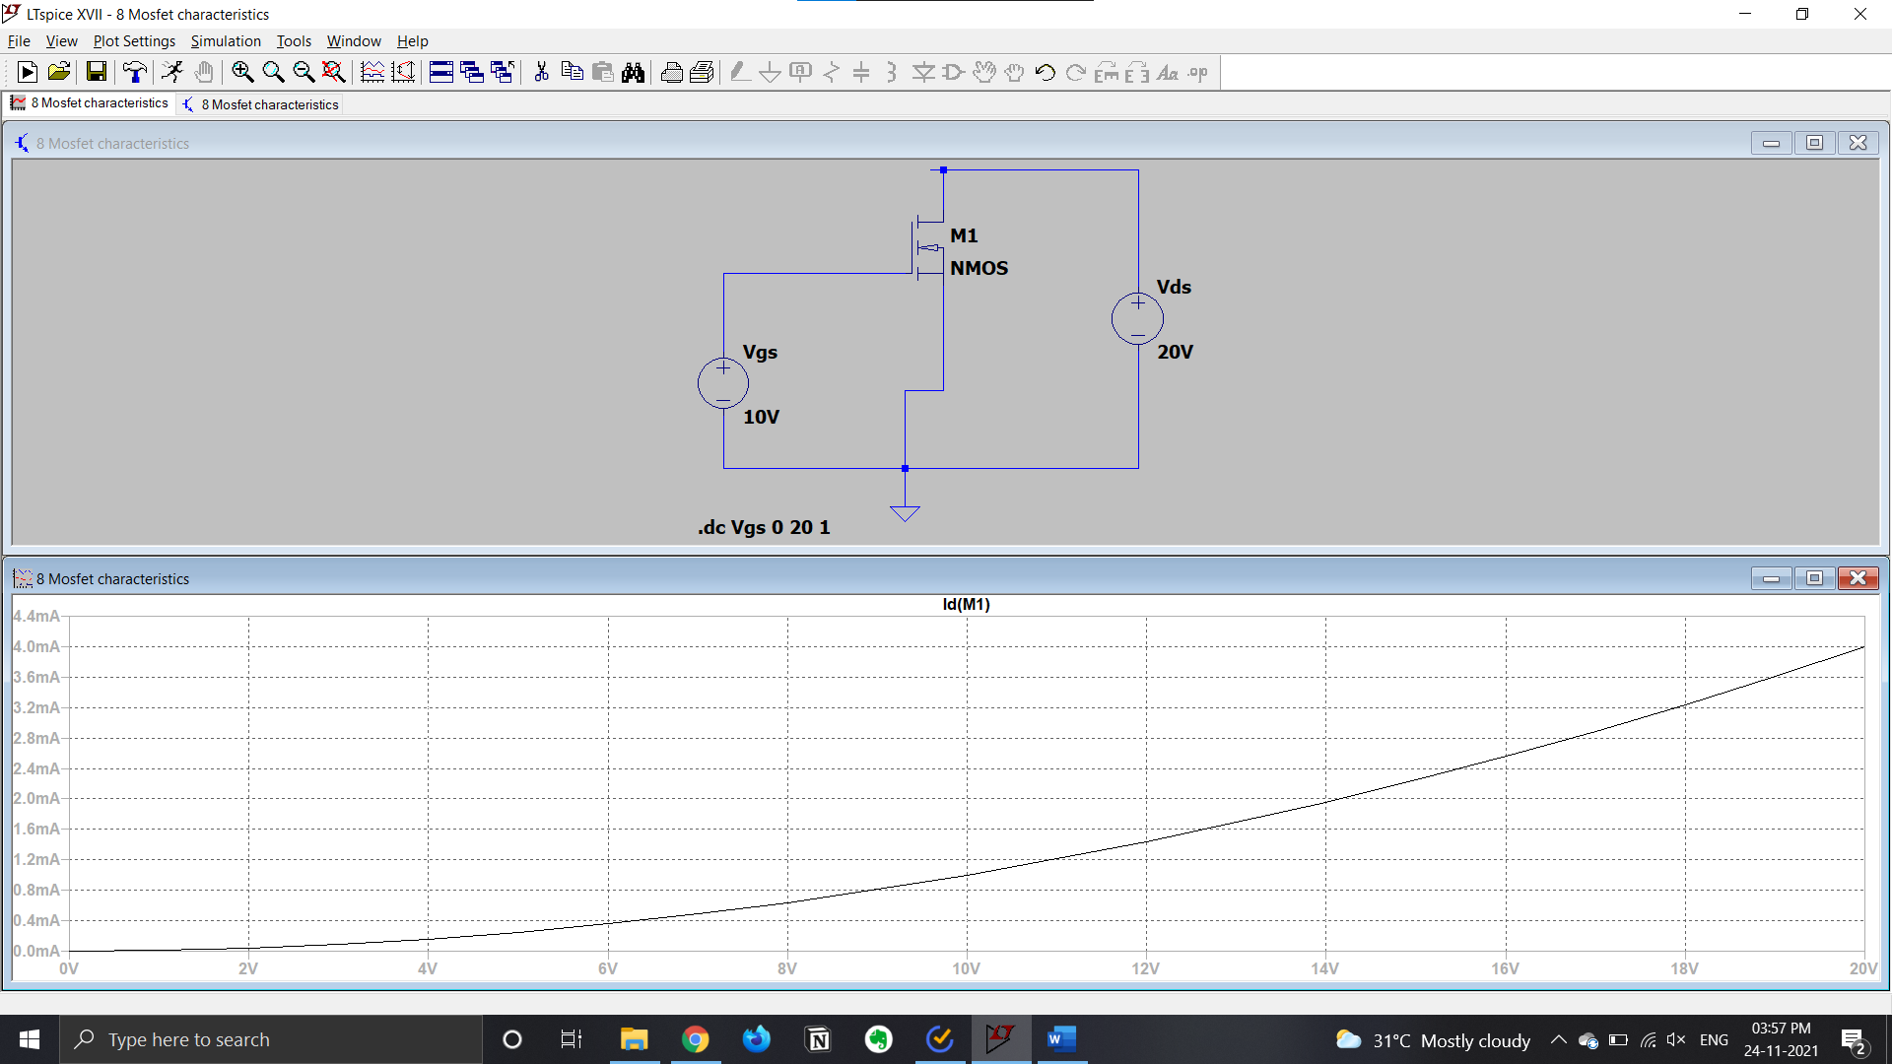

DRAIN CHARACTERISTICS

